# **CTF Topic: Windows Shortcut**

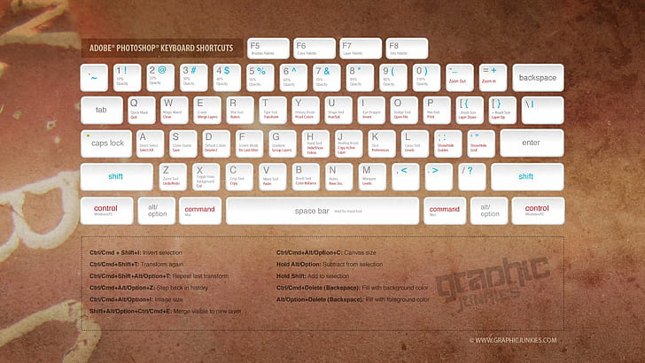

# **1. Introduction**

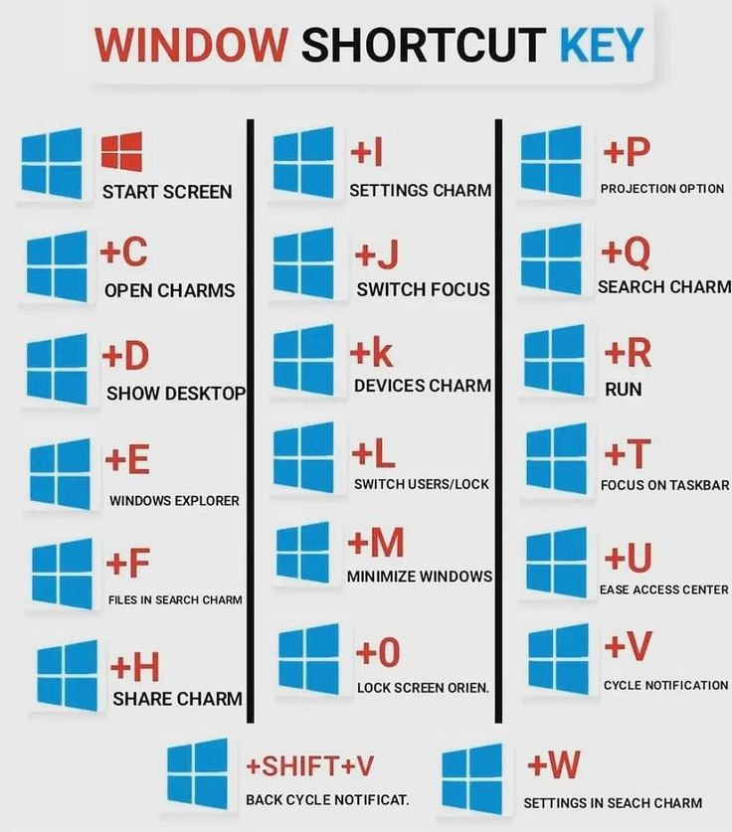

A Windows shortcut is an icon that represents a document, folder, or program file. It allows you to access a file or launch an application quickly and easily by clicking on the shortcut icon. Shortcuts can be placed on the desktop or stored in other folders, and clicking a shortcut is the same as clicking the original file. However, deleting a shortcut does not remove the original file.

# **3. Scenario**



A student in the 10th class has zero knowledge of computer systems. He has an interest in learning about the windows system and security. He just passed the SEE examination and doesn’t know what to do in the coming days. He joined the institute to learn about computers. To start from the beginning the tutor of the institute gave him the simple ctf design to complete which is designed by the ing group. Now, he started to begin the task.

# **Process to Follow while Performing CTF**

Step 1: Search on the browser for an answer.

# Step 2: Capture the flag.

# **Let’s start the Challenge**

# **Question**

**Flag 1: What is the shortcut to creating a new file.**

**Answer: ctrl+shift+N**

**Hint: Control your emotions and shift into the new person .**

**Flag Captured.**

**Flag 2: You are doing this CTF and you are in a café suddenly you want to go to the washroom. You can’t leave your laptop open because unauthorized personnel can do whatever they want. For this you have to lock your computer. What is the shortcut to lock your laptop?**

**Answer: windows+L**

**Hint: lock your window.**

**Flag Captured**

**Flag 3: What is the shortcut to undo action?**

**Answer: ctrl + z**

**Flag Captured.**

# **Hint**

